Module 3: Critical Thinking

Bryan Moffett
Colorado State University Global
ITS410: Database Management
Dr. Raquel Hicks
September 6th, 2026

Using Joins in My Guitar Shop Database
Task 1.3 - Join Categories and Products Tables
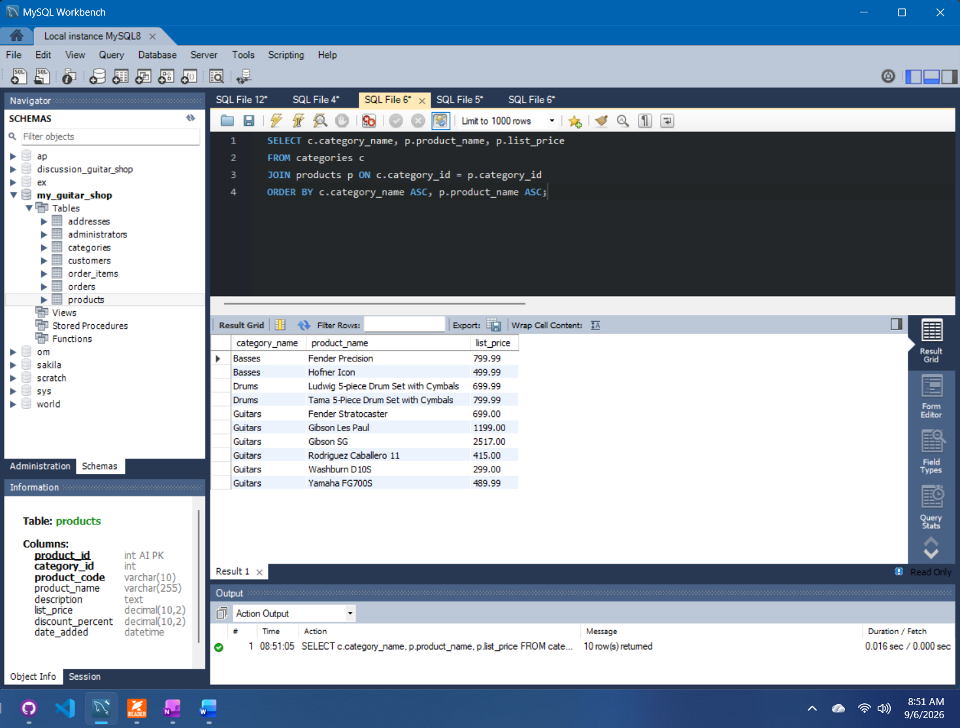

Task 2.3 - Join Customers and Addresses Tables by Email
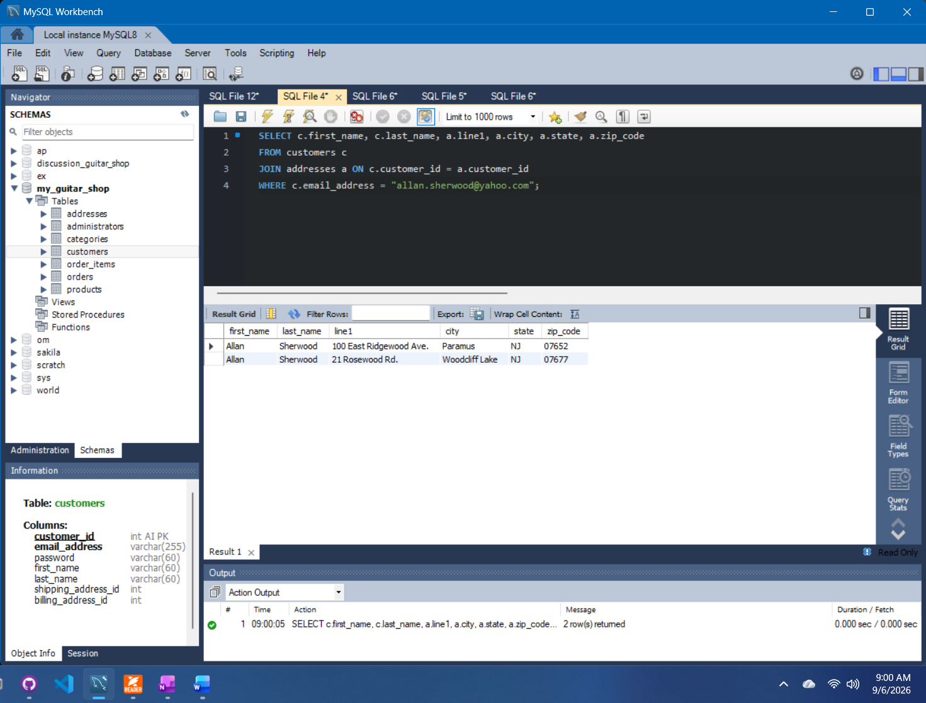

Task 3.3 - Return Only Shipping Addresses for Customers
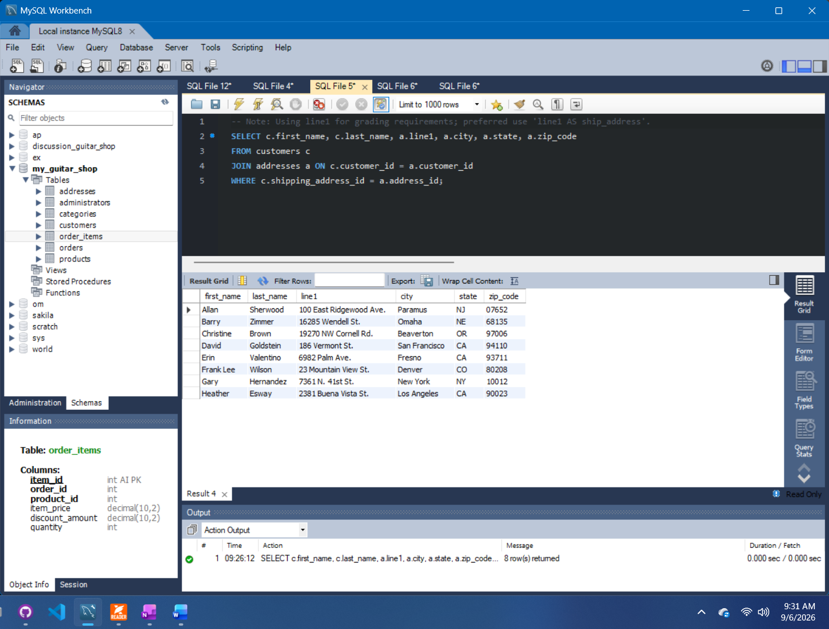

Task 4.5 - Join Multiple Tables to View Order Information
